Catch all the action from the UCI Mountain Bike World Cup presented by Shimano – live on Red Bull TV!

Munich (GER), April 8, 2015 – The UCI Mountain Bike World Cup presented by Shimano is back – bigger and faster than ever before. More teams, more nations and of course, more action. The downhill and cross-country spectacles will provide a thrilling new season, and Red Bull TV will take you right into the heart of it! Who will climb to the top, who will slip up? Red Bull TV will deliver 19 broadcasts from nine countries across two continents, live to your favorite device, wherever you may be. Each edge-of-your-seat broadcast will be hosted by the legendary Rob Warner and Claudio Caluori. Round 1 takes off on April 12, 2015 at 12:30pm GMT/ 03:30am PDT/ 06:30am EDT in Lourdes (FRA). Tune in for the ride!

From April 11 to August 23, mountain bike fans will be gripped by the downhill and cross-country racing action of 130 teams from 33 countries as they contend in the UCI Mountain Bike World Cup presented by Shimano. The goal: to triumph above the rest. For the fourth year running, Red Bull Media House will stream 19 races live (7 DHI, 6 XCO Men and 6 XCO Women) on [Red Bull TV](http://www.redbull.tv/) and [redbull.com/bike](http://www.redbull.com/bike). This year, Rob Warner will lead viewers through the races with his sharp and often hilarious commentary. Supporting him in the booth will be Claudio Caluori, already a fan favorite for his course previews last season. Get a taste of what commentary madness to expect this season with Claudio’s 2014 highlights: <http://win.gs/ClaudioCaluori_Highlights>.

The season will kick off at a new race venue, Lourdes in France, on April 12. The downhill track in the Pyrénées – 2.5km (1.24 mi) long and descending 470m (0.29 mi) – is unknown terrain for most of the athletes. French riders who have challenged for the Coupe de France or trained in the region, like Loic Bruni, may feel right at home down these fast and furious lines. But the reigning Champions from Great Britain will be there, looking to continue their winning streak. Gee Atherton will ride hard to win back the crown from last year’s Champion Josh “Ratboy" Bryceland. Not to mention Gee’s sister, Rachel Atherton, who has more than one bone to pick with 2014 Champion Manon Carpenter.

And the UCI Mountain Bike World Cup presented by Shimano is not just about who can get down a hill as fast as possible. The cross country riders are also raring to go. Julien Absalon vs. Nino Schurter, Jolanda Neff vs. Catharine Pendrel – who has the [power](http://www.dict.cc/englisch-deutsch/power.html) to grab the 2015 title?

Here is an overview of all the races and broadcast times on Red Bull TV:

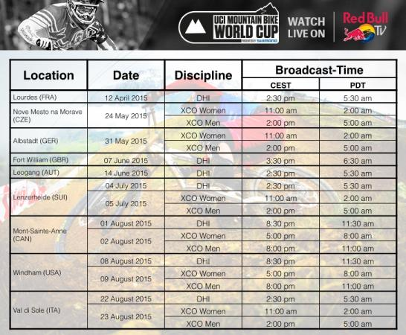

Don’t miss a single moment of live racing action this season. Red Bull TV will broadcast the UCI Mountain Bike World Cup, live on Red Bull TV – online and on mobile via Android, iOS and Windows Phone, as well as on selected partners’ platforms such as Apple TV, Xbox 360, Amazon Fire TV (US), Chromecast and as a pre-installed channel on Samsung Smart TVs (2011+) in 194 countries.

About Red Bull Media House

Red Bull Media House is a multi-platform media company that focuses on sports, culture, and lifestyle topics. It offers a wide range of premium media products and compelling content across media channels as diverse as TV, mobile, digital, audio, and print, with core media offerings that appeal to a global audience. Besides creating content and operating media platforms that address consumers directly, Red Bull Media House also offers a vast range of targeted business opportunities for partnerships with other companies, media partners and affiliates. These include content distribution and licensing, brand partnerships, and advertising in our media. For more information please visit [www.redbullmediahouse.com](http://www.redbullmediahouse.com/).

Reprint free of charge

Specimen copy requested

Contact:

rasoulution GmbH

Sabrina Rill

Thomas-Wimmer-Ring 9

80539 München

Email: [high@rasoulution.com](mailto:high@rasoulution.com)

Phone: +49 (0)89 3866709-17